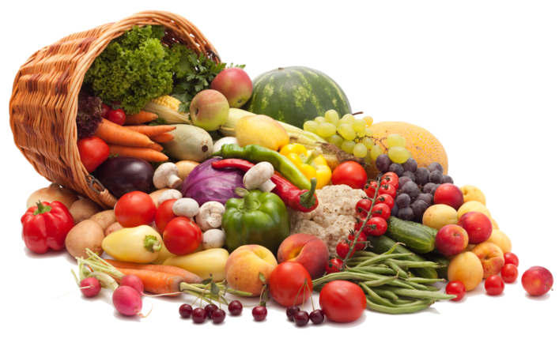 **Emma Hutchinson School Market**

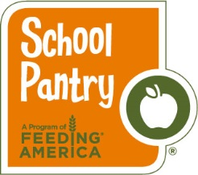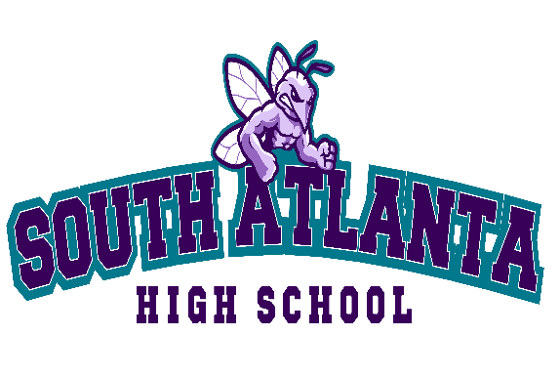

**A mobile market in partnership with the Atlanta Community Food Bank. Free while quantities last – Eligible to all families at the participating school.**

Come participate in a monthly market featuring assorted food items and **fresh produce!** Families may receive approximately 30 lbs of food items free of charge to take home and prepare. **DON’T FORGET TO BRING BAGS OR A CART!!**

**Next Date: Tuesday, February 15 , 2022**

**9:00-a.m. - 12:00 p.m.**

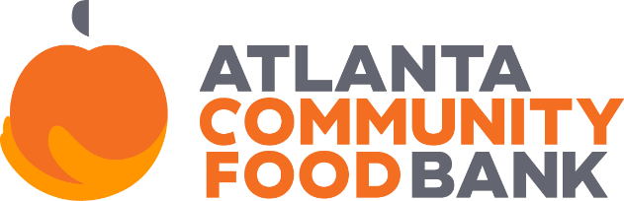**Where: Hutchinson Elementary School**

**650 Cleveland Avenue**